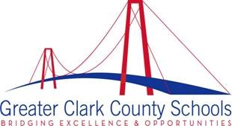

**Preschool 2023-2024 FAQs**

* When can I apply for preschool?
  + 2023-2024 applications for GCCS preschool program will open up at the beginning of March. An exact date will be shared via social media and in building communications as soon as it is determined.
* Where do I apply for preschool?
  + Once available, the application will be available on the Greater Clark County Schools website under the Parent tab, then Preschool Application.
* How old does my child need to be to attend preschool?
  + To be eligible for preschool students MUST be 4 years old on or before August 1, 2023.
* What preschool programs are available?
  + Half day and full day programs are available.
  + Various factors determine placement in the program including the time the application was received.
* Is there financial assistance?
  + Families will need to apply for OMWPK using the link in the application. This is a requirement.